LAB ManualPART A

(PART A : TO BE REFERRED BY STUDENTS)

**Experiment No.03**

**A.1 Aim:**

Identify the project from any of the following application domains as per the current market needs.

* Health Care
* Food industry
* Education
* Business Intelligence etc.

Prepare the business proposal for selected problem.

**A.2 Prerequisite:**

Understanding of Business proposal and component of Business Praposal.

**A.3 Outcome:**

**After successful completion of this experiment students will be able to:**

Define project proposal by covering following points.

1. Project Sponsor
2. Business Need
3. Business Requirement
4. Business value
5. Special issue or constraints

**A.4 Theory:**

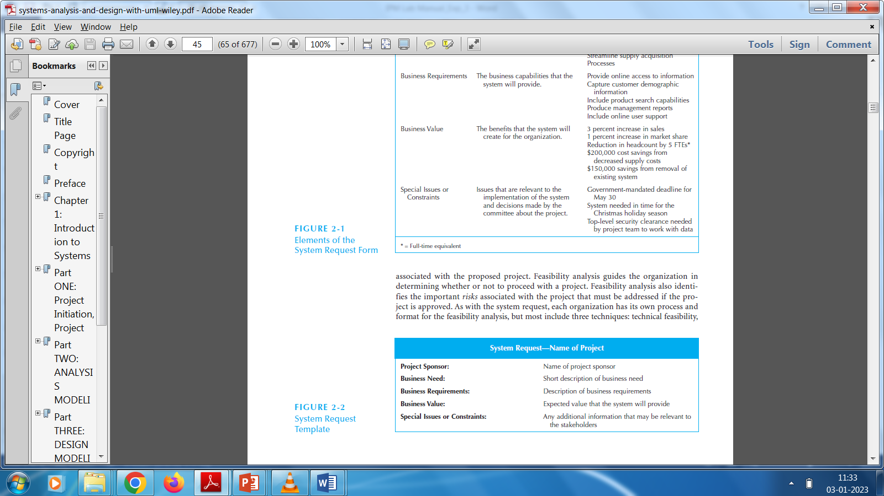

**A.5 Procedure/Algorithm:**

**Sample format of proposal,**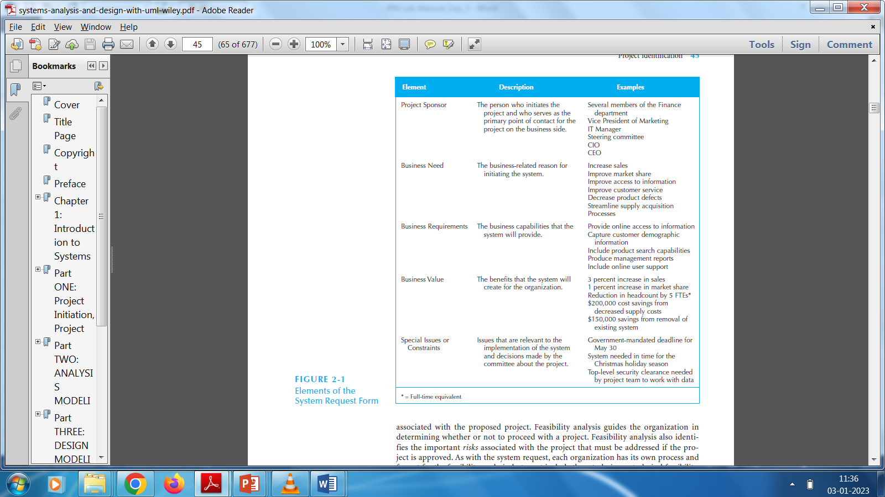

PART B

(PART B : TO BE COMPLETED BY STUDENTS)

***(Students must submit the soft copy as per following segments within two hours of the practical. The soft copy must be uploaded on the Blackboard or emailed to the concerned lab in charge faculties at the end of the practical in case there is no Black board access available)***

| Roll No. A016,A018,A022 | Name: Varun K,Simran K, Kartik P |
| --- | --- |
| Class : B.Tech CsBs | Batch : 1 |
| Date of Experiment: 09-01-2023 | Date of Submission: 09-01-2023 |
| Grade : |  |

**B.1 Answers of Task to be written by student:**

| **Element** | **Description** |
| --- | --- |
| Project Sponsor | Faculty Mentor: Dr. Toral Shah, NMIMS, Navi Mumbai |
| Business Need | In the past, room service was a luxury offered by hotels, but it has become a drain on resources, and some hotels have stopped offering it. However, the trend is changing with the introduction of room service apps, which allow guests to order food and services through their phones and have them delivered to their rooms. These apps can help hotels improve marketing, customer service, and the guest experience. However, The existing room service mobile apps have limitations currently, the only language offered is English, and some reports say the system is quite slow and has many unresolved bugs, glitches. Also, many of the listed apps and websites are not available. The ones available either have compatibility issues with the devices or have a very unfriendly interface. The goal of this project is to develop a room service app that addresses these issues and provides a comprehensive solution for hotels to improve the guest experience. |
| Business Requirements | Goal of the project is to provide a framework that hotels might utilize to execute the idea of smart hotels and to assist them in raising customer engagement and satisfaction levels. Therefore, we aim to create a mobile app that, in a sense, would speed up interactions between hotel staff and customers and enable them to communicate with one another. In addition, we wish to provide as much guest-related information as possible, which will enable hotel managers to easily access the required information. The guest-related information will be up-to-date, so that hotel managers can connect with their guests more accurately and more effectively while they are away from their desks. In addition, the app developed is designed to be able to analyze the characteristics of the guests, as this is a critical function that hotel management can use to meet their guests’ expectations and provide more personalized services in a timely manner, thus increasing the  customers’ satisfaction and increasing the rate of returning customers. |
| Business Value | * Provide Customer satisfaction: By providing an easy and convenient way for guests to order food and providing multi-lingual facility and includes descriptions of their order and get real-time updates on order confirmations through notifications without the need to converse with the manager, also customer can place housekeeping and luggage pickup requests using the app as well as make advance reservations to restaurants and spas within the hotel and booking slots for the delivery of services. * Increased revenue: The app can help hotels generate additional revenue by providing guests with more options for ordering food and services, and by making it easier for guests to make purchases. * Cost savings: By reducing the need for phone-based room service, the app can help hotels save on labor costs and improve operational efficiency. * Marketing opportunities: The app can provide hotels with a platform for promoting special offers and packages to guests, and for gathering customer feedback and reviews. * Enhanced brand image: By offering a modern, tech-savvy solution for room service, hotels can improve their image and differentiate themselves from competitors. |
| Special Issues or Constraints | * Device requirements: The user’s device would require some minimum storage space and RAM. * Connectivity: The app needs a good internet connection to operate. |

**B.2 Observations and learning:**

***(Students are expected to comment on the output obtained with clear observations and learning for each task/ sub part assigned)***

Through this practical, we could briefly examine the project's business scope, potential needs, requirements, and potential value fulfilment. Some important aspects like storage and connectivity were acknowledged in the context of needs. By examining the market need, project needs, and how it adds value to businesses, this activity aided in understanding the business aspect of an IT project. The provision of a service with a scalable, adaptable, easy-to-use application that promotes revenue, enhances customer loyalty, and raises NPS and GSS may be clearly defined as the projects' primary goal.

**B.3 Conclusion:**

*(****Students must write the conclusion as per the attainment of individual outcome listed above and learning/observation noted in section B.3)***

As a result, we were able to recognise the significance of a business proposal in terms of analysing the project's scope, requirements and identifying crucial elements that provide businessl value.